# Electronics

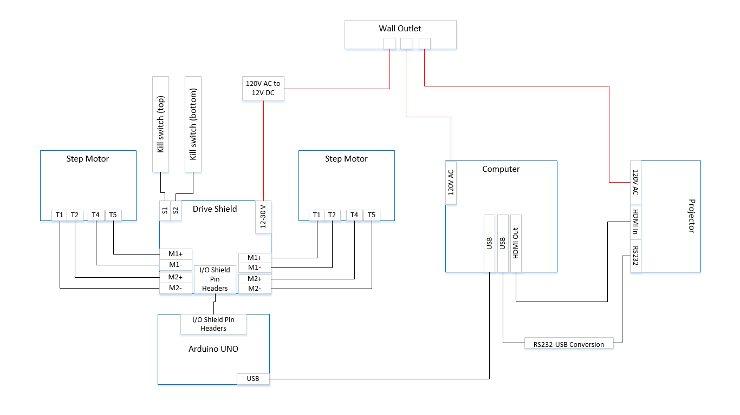

Figure 1

## Motor and Motor Control

The lead screws of the printer are driven by two NEMA 17 bi-polar stepper motors. These two lead screws turning in one direction or the other will cause the chassis to move up or down, and thus move the build table up and down. This vertical movement is what always the object to be built layer by layer. The motors each produce a holding torque of 200 mN-m at 12 volts and pull 0.35 A per phase. Full motor specifications are listed in Table X (adafruit.com).

Table 1

|  |  |  |  |
| --- | --- | --- | --- |
|  | Stepper Motor Data | | |
| Drive Method | | Bi-Polar |  |
| Number of Phases | | 2 |  |
| Step Angle | | 1.8 | deg/step |
| Voltage | | 0.35 | V |
| Current | | 0.34 | A/phase |
| Winding Resistance | | 4.3 | I/phase |
| Inductance | | 200 | mH/phase |
| Holding Torque | | 11.8 | mN-m |
| Detent Torque | | 38 | mN-m |
| Rotor Inertia | | 0.21 | g-cm2 |
| Weights | | 0.57 | g |

The motors are controlled by a CNC shield that implements four Pololu motor drivers. The original design called for an Adafruit motor shield that supported H-bridge drive techniques due to its low cost popularity within the field. However, the GRBL software that sends movement commands to the drive shield requires specific motor acceleration variables that are not supported by H-bridge drivers. Much effort was spent trying to remedy this problem, however we eventually learned that this was not a practical solution. Adding H-bridge support to the system would have required developing brand new firmware from scratch, and our team simply did not have time to complete such an endeavor. After this had been determined, the CNC shield was selected as a replacement solution. The CNC shield is advantageous for our purposes because the shield directly handles all acceleration parameters needed to drive the motors. Another advantage is the Pololu drivers are cheap and are easily replaced if they were to ever be damaged.

## Health and Safety Concerns

A consequence of stepper motor design is that they pull high current due to the reactance in the winding of the motor. As mentioned previously, each two phase motor is pulling 0.35 A per phase, which means each motor is pulling 0.70 A. The drive shield has a built-in potentiometer which allows the user to adjust the maximum current pulled through the shield however a certain amount of current is needed to maintain holding torque. Even with adjusting the potentiometer the printer has been shown to pull nearly 0.90 A while in operation. This amount of current can be very harmful to a user and can even lead to death through ventricle fibrillation. Because of this risk a user must familiar with electric current be extremely careful when operating the machine.